By American Express

TeAM NAME: GIRL’S HIVE

1. Aastha Kanth
2. Pooja Gusain
3. Ruby Chawla
4. Jiya Sharma
5. Ankita Das

MAKEATHON 2023

**Theme**

**ML Model- Fraud Detection**

**Colab Notebook:**

<https://colab.research.google.com/drive/1mGDx7nXO66DcGq4xSOEFzXTThu_opzVZ?usp=sharing#scrollTo=pqA2yBNIPHPH>

Problem Statement:

To build an ML model for detecting credit card fraud by using an imbalanced dataset.

Fraud can be detected in various forms and one of the major forms of it is credit card fraud. Earlier these frauds were detected by human-proposed patterns and rules to rely upon. This was time-consuming as well as the accuracy level of detecting fraud was unmonitored and was incapable of detecting a new fraud pattern.

Solution:

The ML model will be trained on the dataset so as to detect real-time fraud patterns. This will reduce the time consumption as well as the accuracy level of the model will be defined and could be refined over time.

The dataset was taken from Kaggle for building the model:

<https://www.kaggle.com/code/bannourchaker/frauddetection-part1-eda/input>

The dataset consisted of 11 columns out of which 1 column was for the label ‘isFraud’ which consisted of ‘0’ and ‘1’ values indicating,

‘0’ for non-fraudulent transaction

'1’ for fraudulent transactions

Out of the remaining 10 columns, only 6 columns were taken as the features of our model.

Since the label consists of only 2 predictable values 0 and 1, it comes under binary classification and hence, we developed the model based on **Logistic Regression.**

Methodology:

* Architecture Diagram

Data Collection:

The dataset was downloaded from Kaggle and was accessed from a local repository.

Exploratory Data Analysis:

We first noted the shape of the dataset and then regarding the type of each column used in the dataset. We the analyses the mean, standard deviation and percentile value for each feature.

We then look for noise (i.e. null values) in the dataset, for this dataset we were not able to find any noise.

We then stored the feature names in a separate list for easy access. These features then undergoes scaling.

Pre-Processing:

We look for the outliers present in each feature by visualising them via boxplot from seaborn plot. We the removed these outliers using interquartile range (IQR) since the probability distribution graph for the features is skewed. We then noted the new shape of the data frame after removal of outlier.

Next we processed to check the imbalance in the dataset, and we noted that the non-fraudulent values are greater in number by a large sum as compared to the fraudulent data.

Modeling:

The dataset was split into a ratio of 7:3 for train and test dataset and non-randomization of train and test values was set. We then observed the shape of features for train and test set and the for the labels of test and train.

We removed the imbalance in the train dataset by using SMOTE and then observed if the dataset was balanced or not for fraudulent and non-fraudulent values.

Logistic Regression:

We now proceeded to fit the training dataset into the logistics regression model and then observed the precision, recall and f1-score of the model.

Optimal Result of the model:

We then created a confusion matrix for the evaluation on the model that we have built.

Later, we recorded the f1-score , accuracy score, MSE(mean square error) and recall score for the predictions that were made by the model.

* Flow Chart

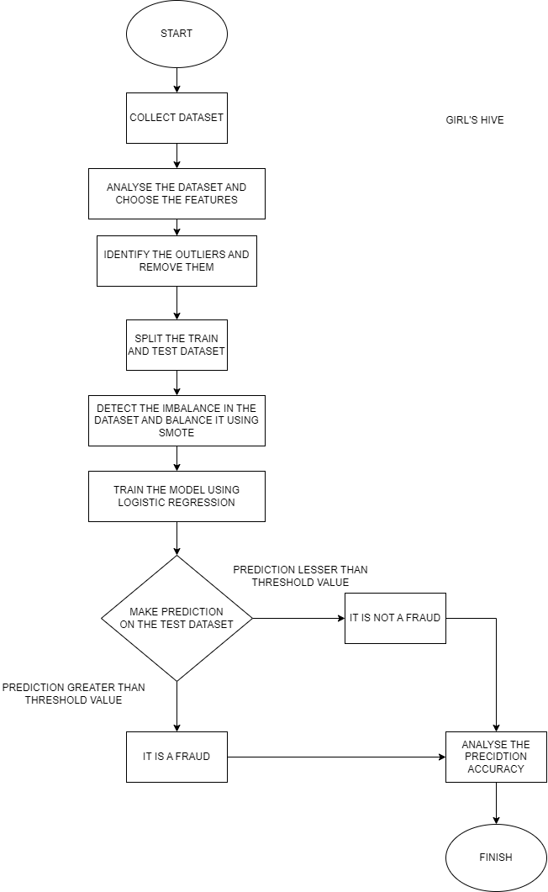

* Graphical representation

The box plot to view the outliers present in the dataset were obtained as follows:

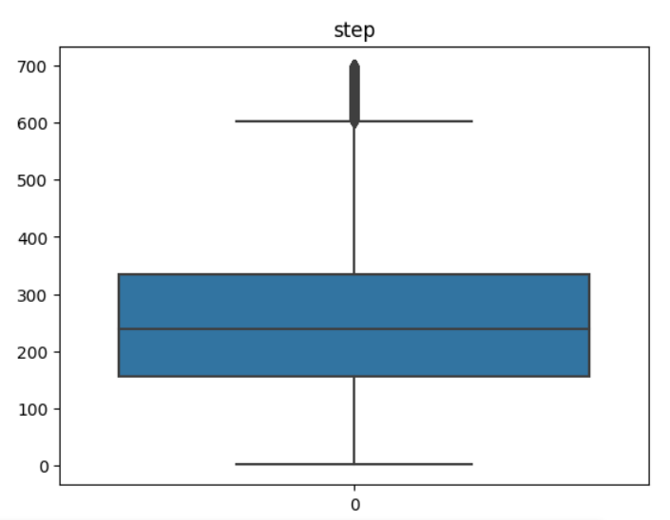

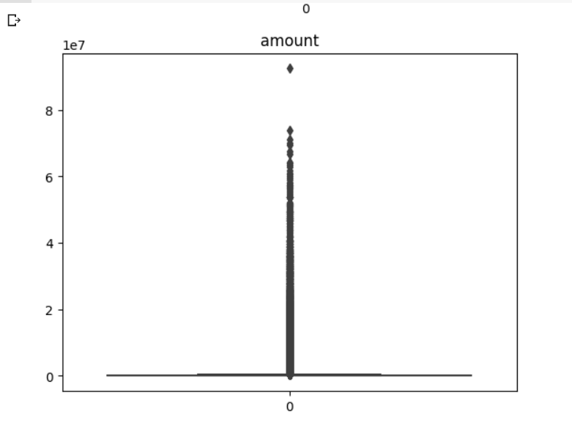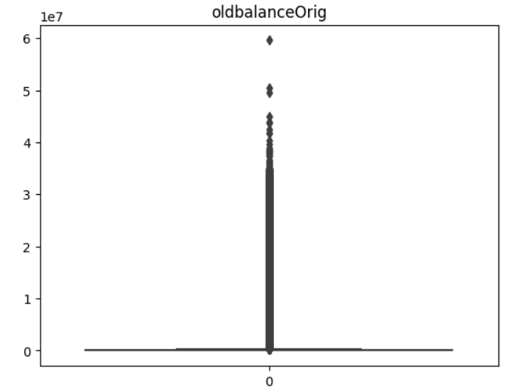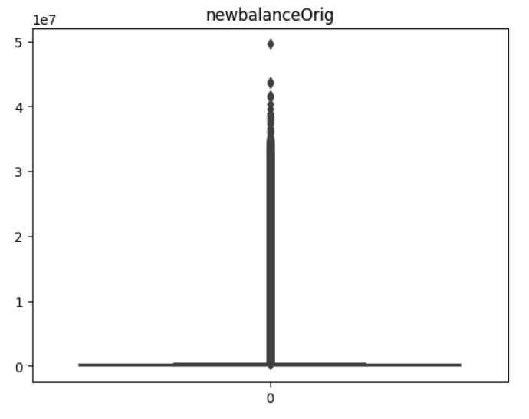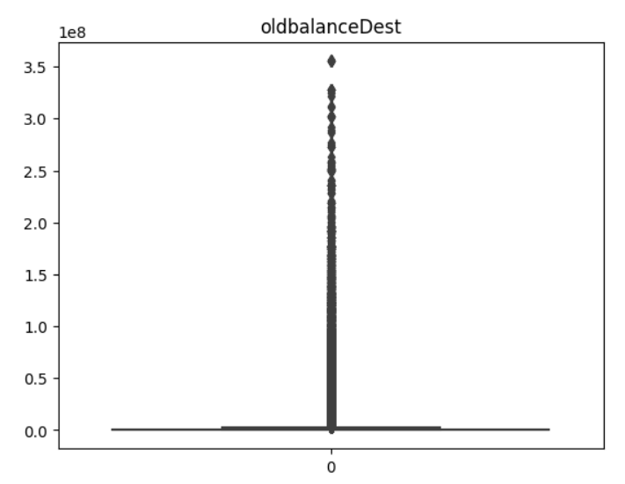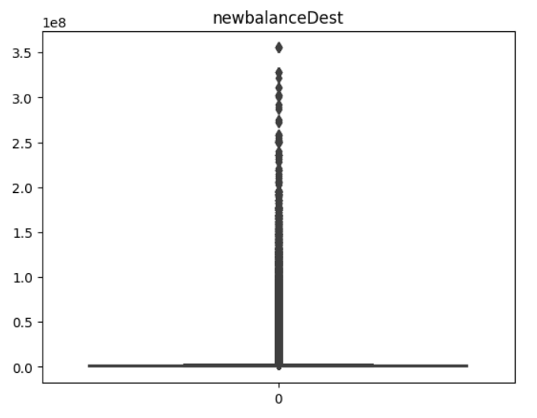

Further the imbalance in the dataset was noted by a bar graph:

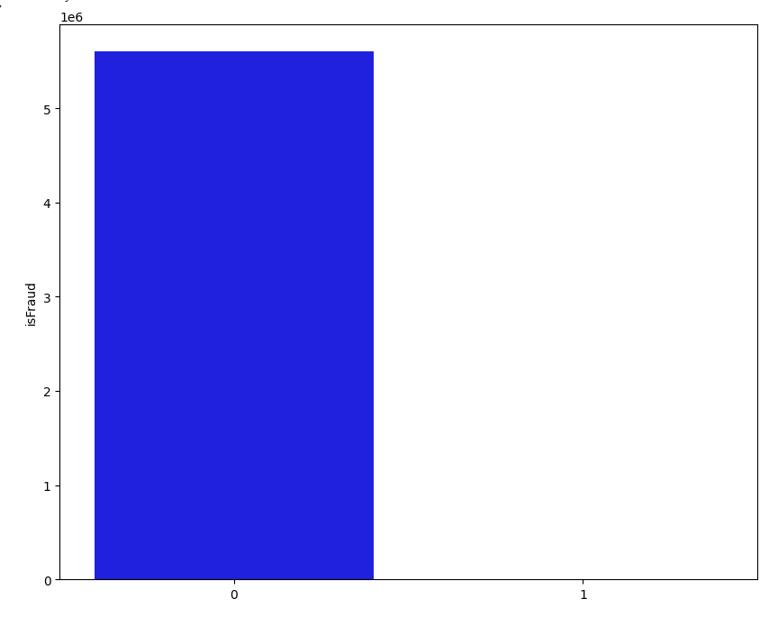

Heatmap for the correlation of features:

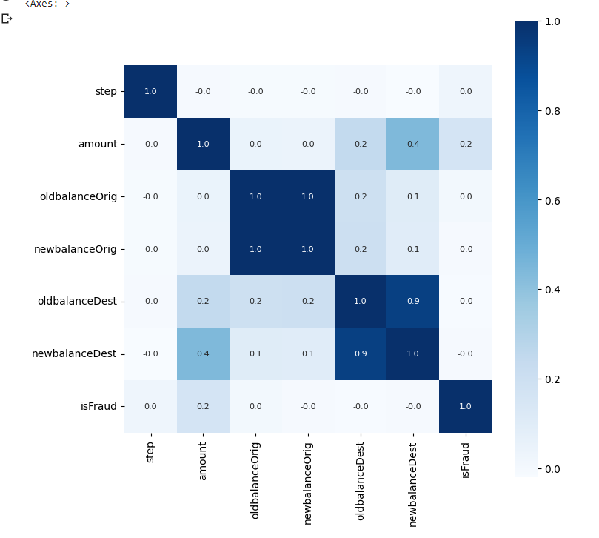

* Prototype ( Screenshot, Screencast, Image, Video etc. )

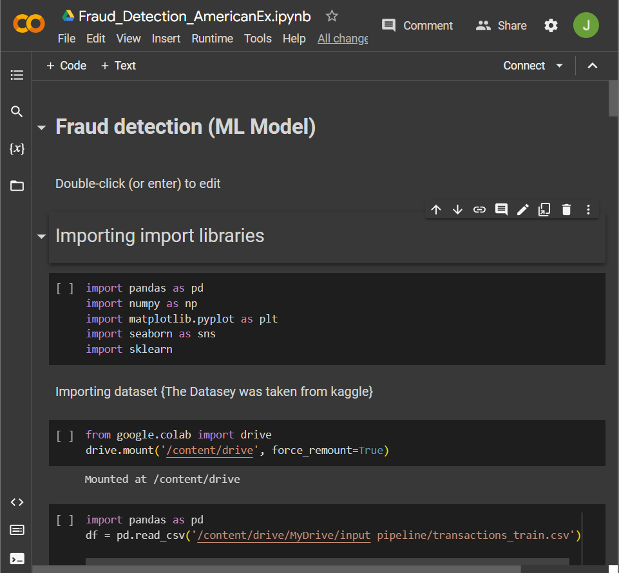

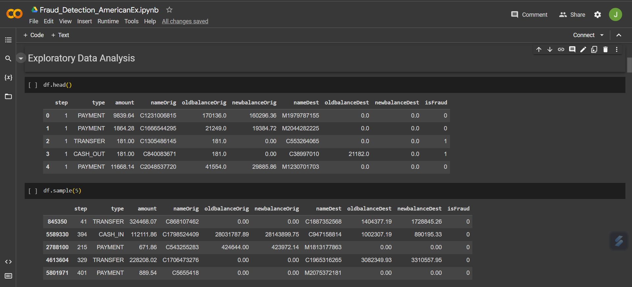

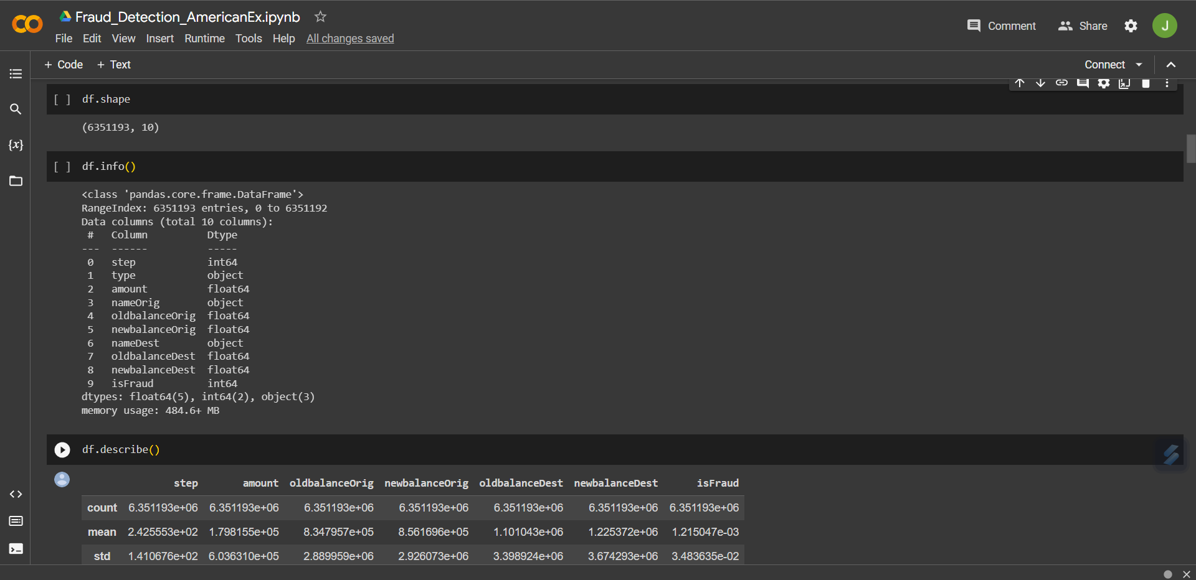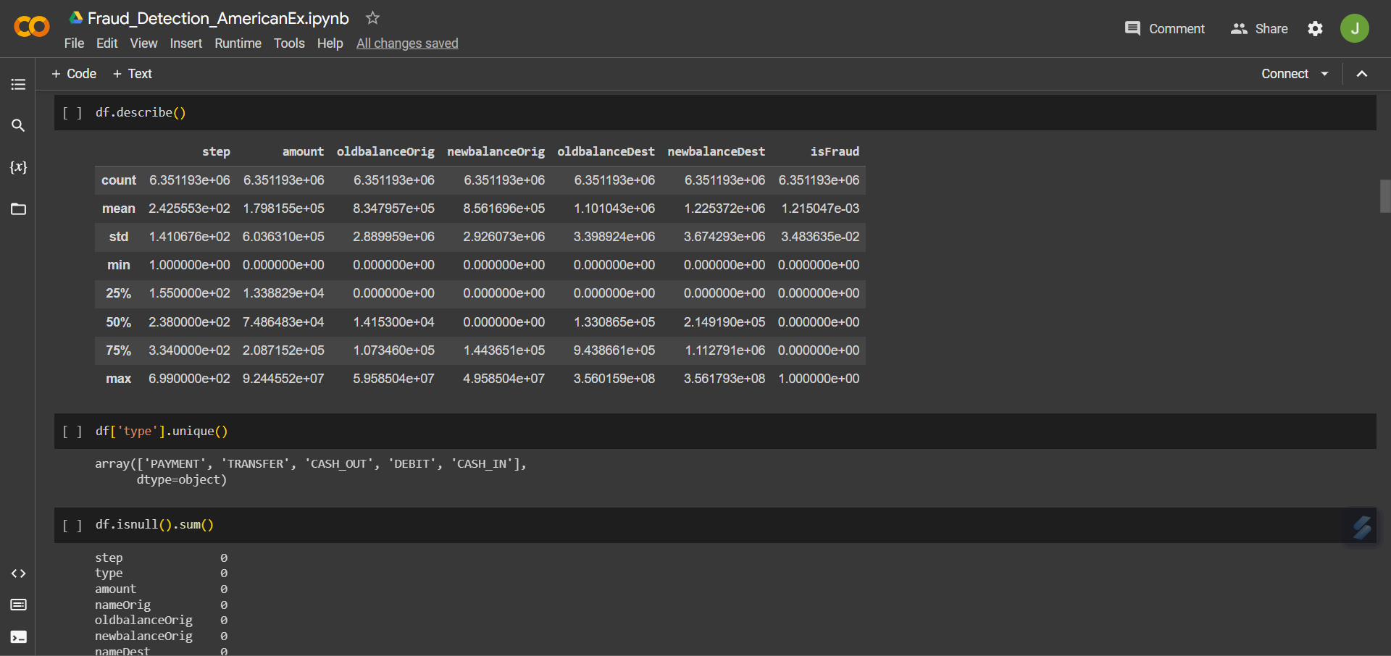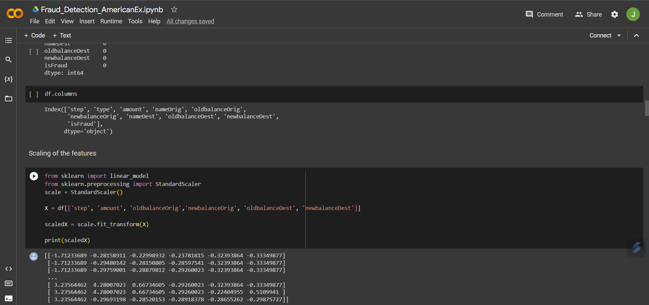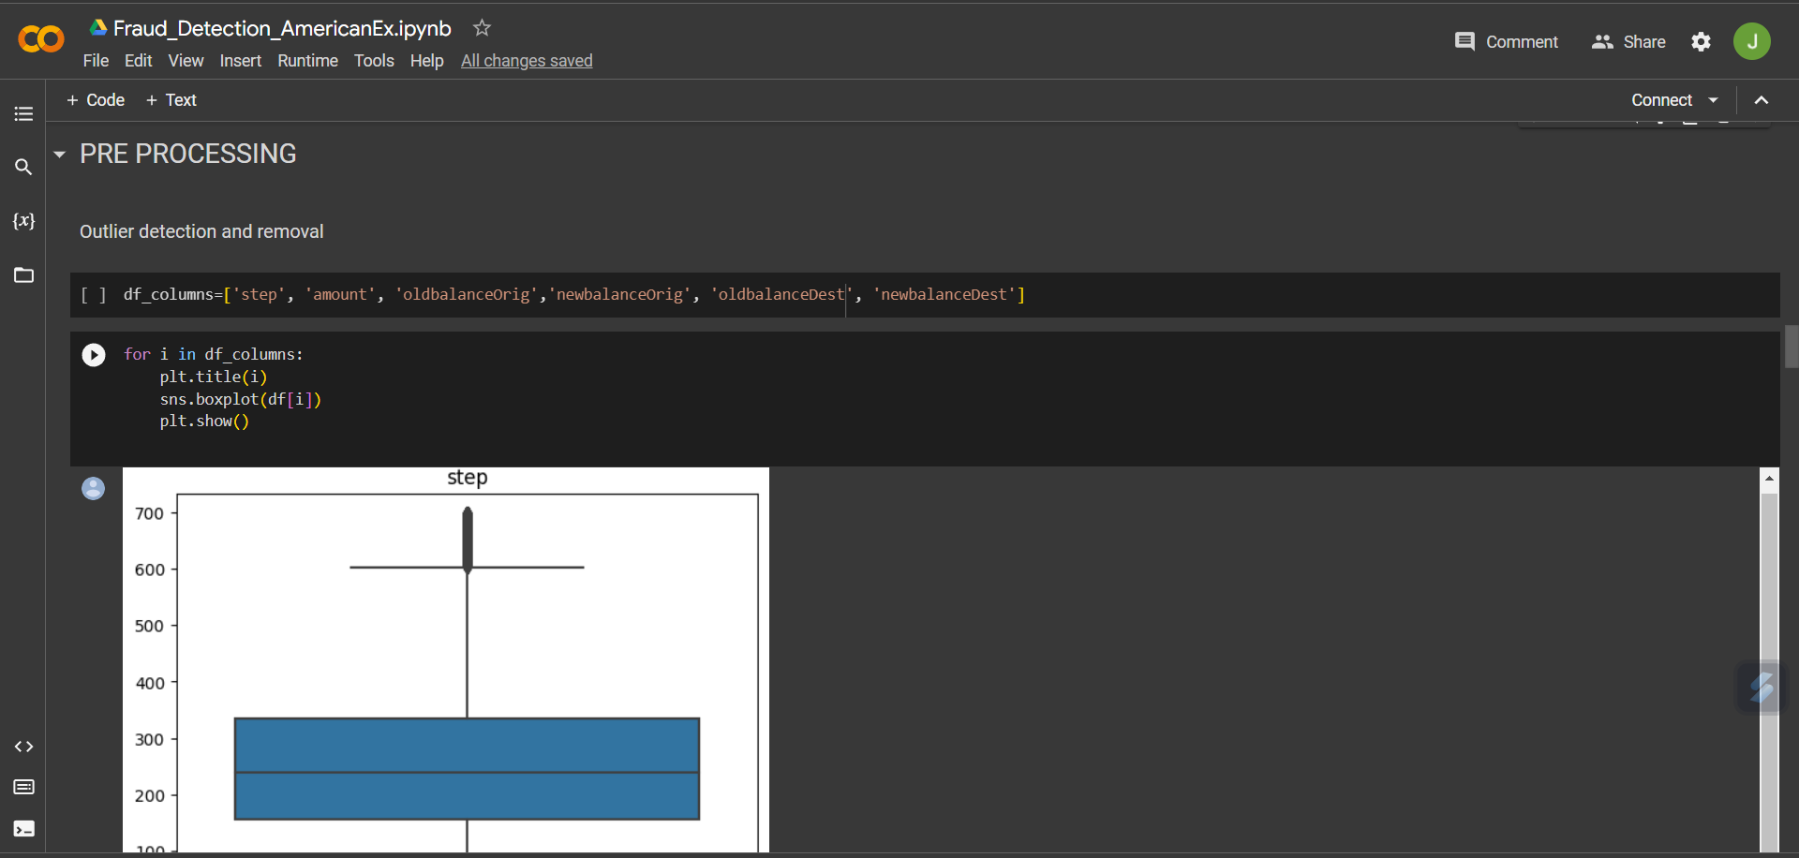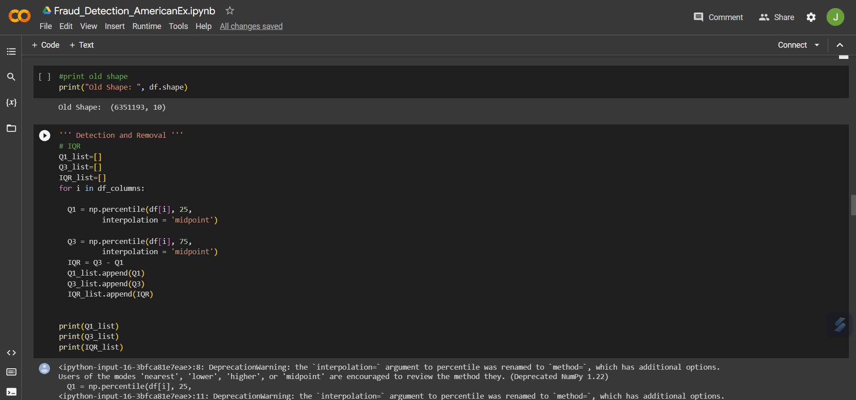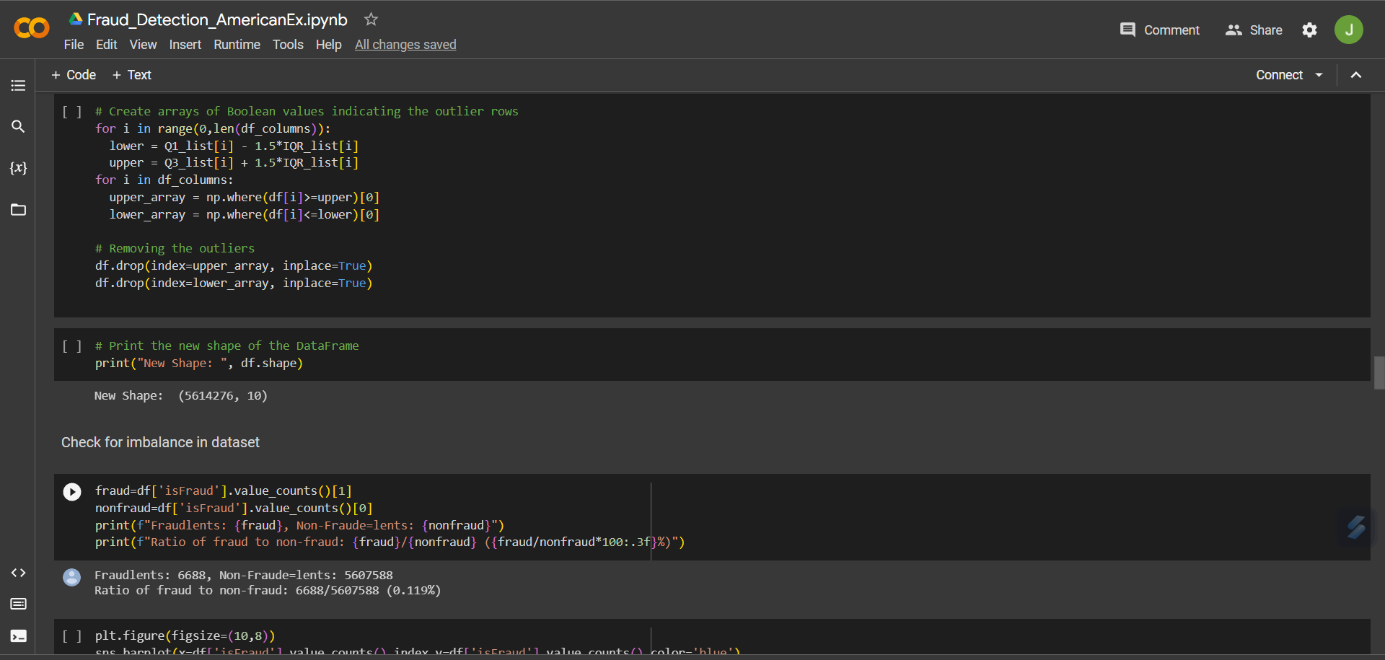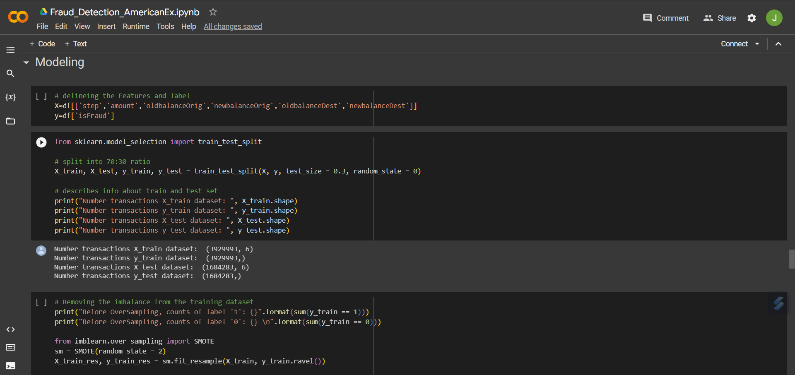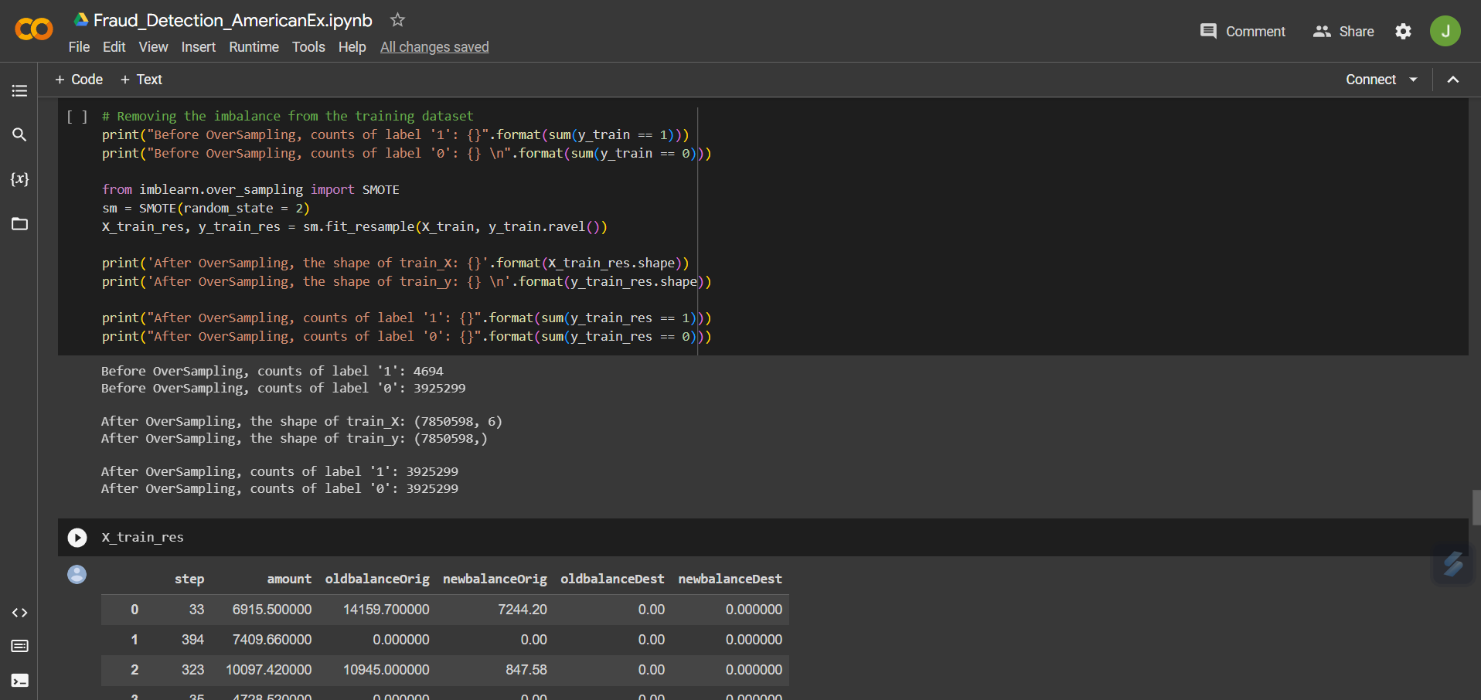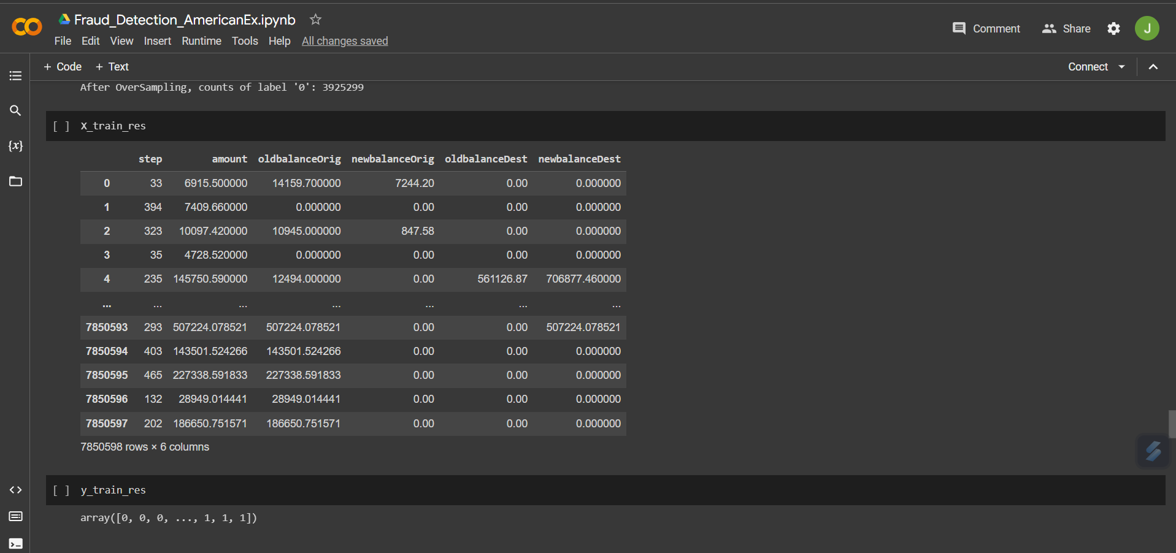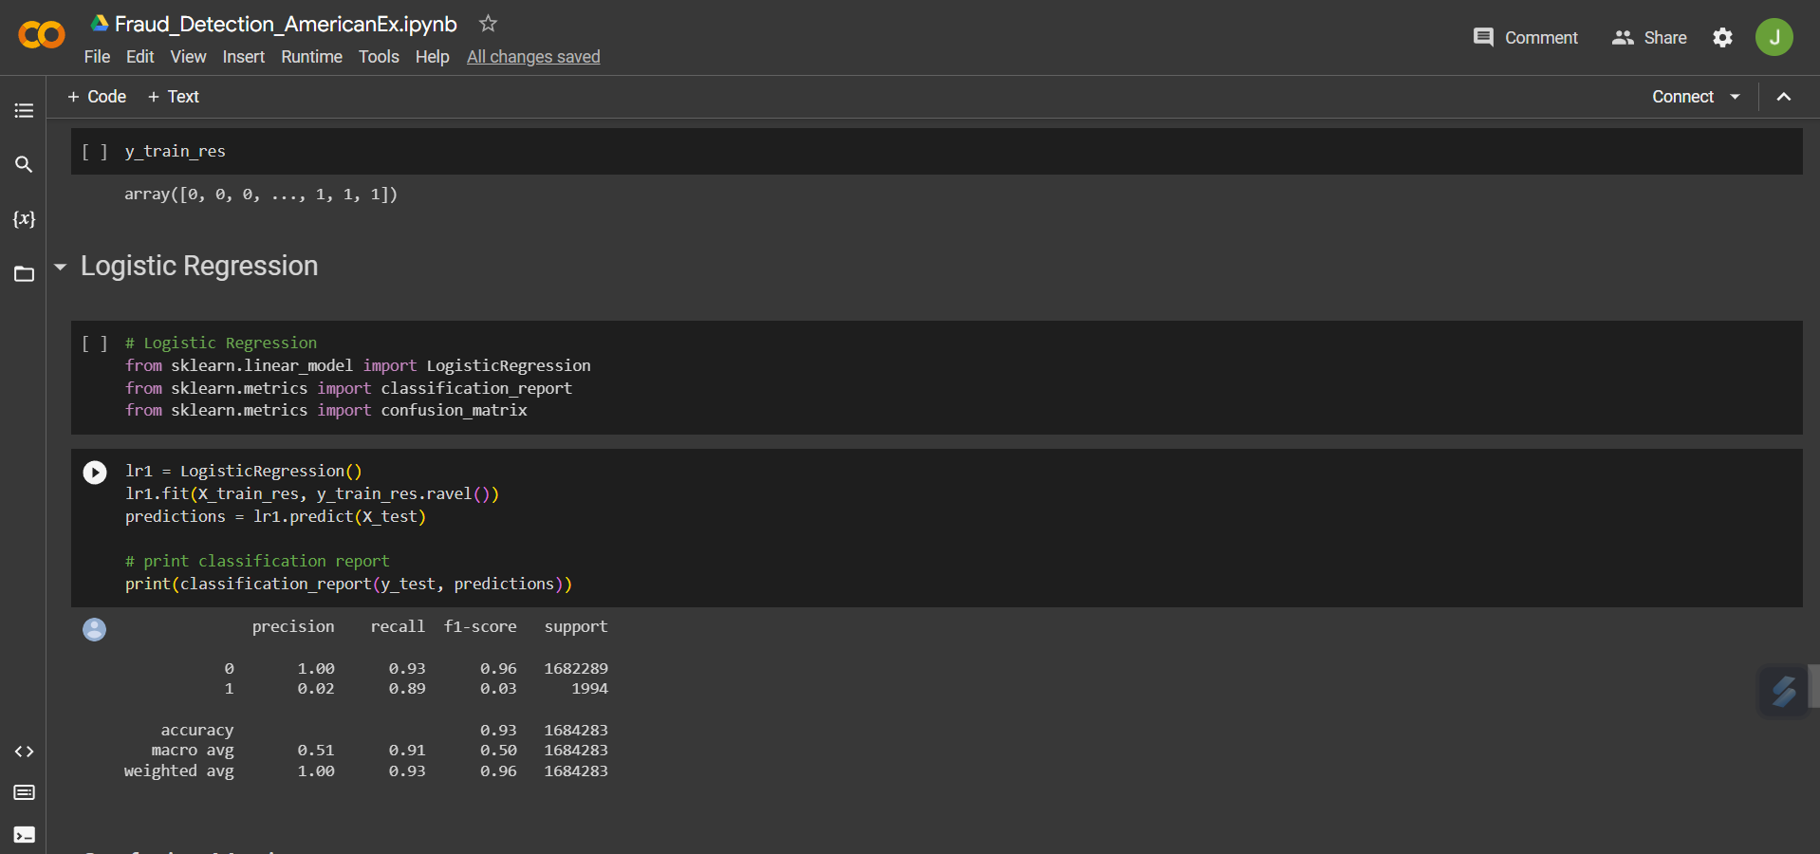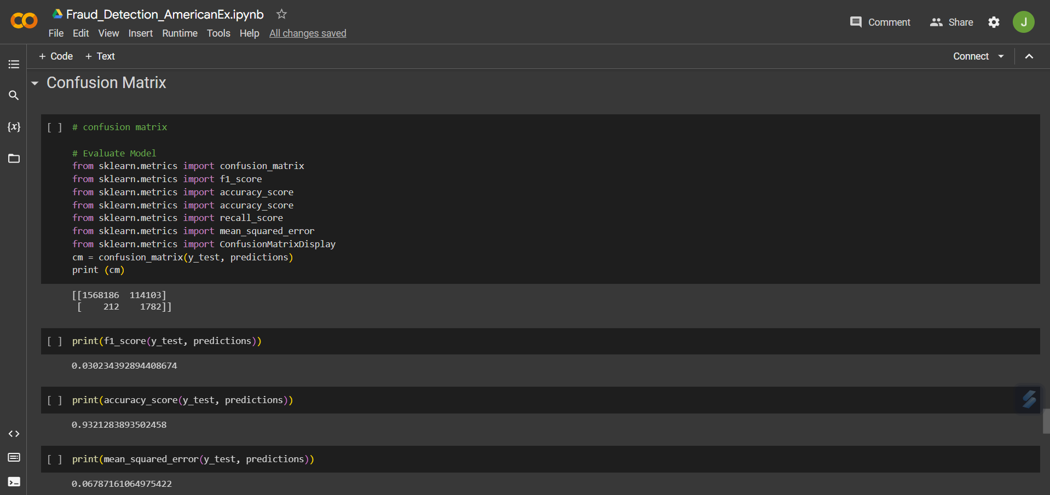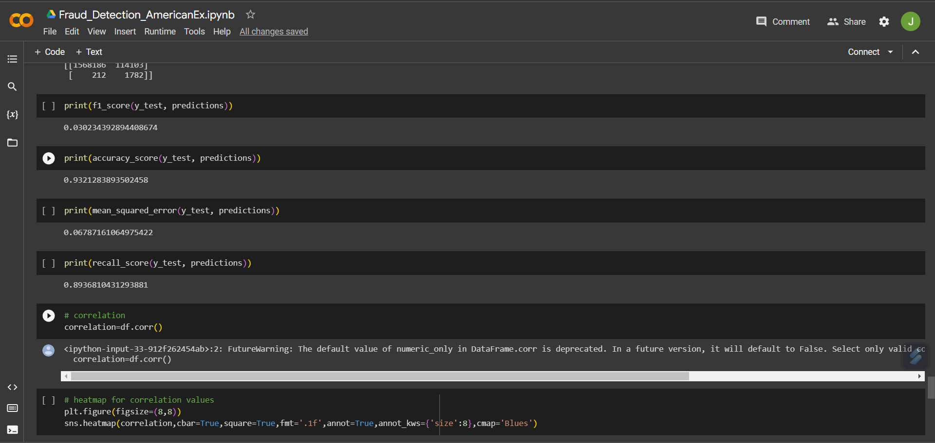

Societal Impact/ Novelty:

This model will have a major impact on creating a safe and strong interface for the transaction of money from source to destination account. Thus, the fraud rate via credit cards will get reduced in no time.

The model will learn new patterns and possibilities along with the dataset it encounters in real-time. Making the prediction of the model more accurate.

This will be a great asset for the business and finance sector as the money will undergo a safer transaction route. This will also ensure to build a higher security in the cyber world.

Future Scope:

This model can future be integrated with other algorithms like SVM, random forest, etc to create a hybrid machine learning model in order to achieve a higher rate of accuracy.

This model can further be deployed for a wide range of use and easy accessibility for society. The columns which were not used as a feature in the model like source account number and destination account number will be used to detect the origin of the fraud.

********************